DevOps

Systems Manager 2

Session Manager 2

Elastic Bean Stalk 4

# Systems Manager

## Session Manager

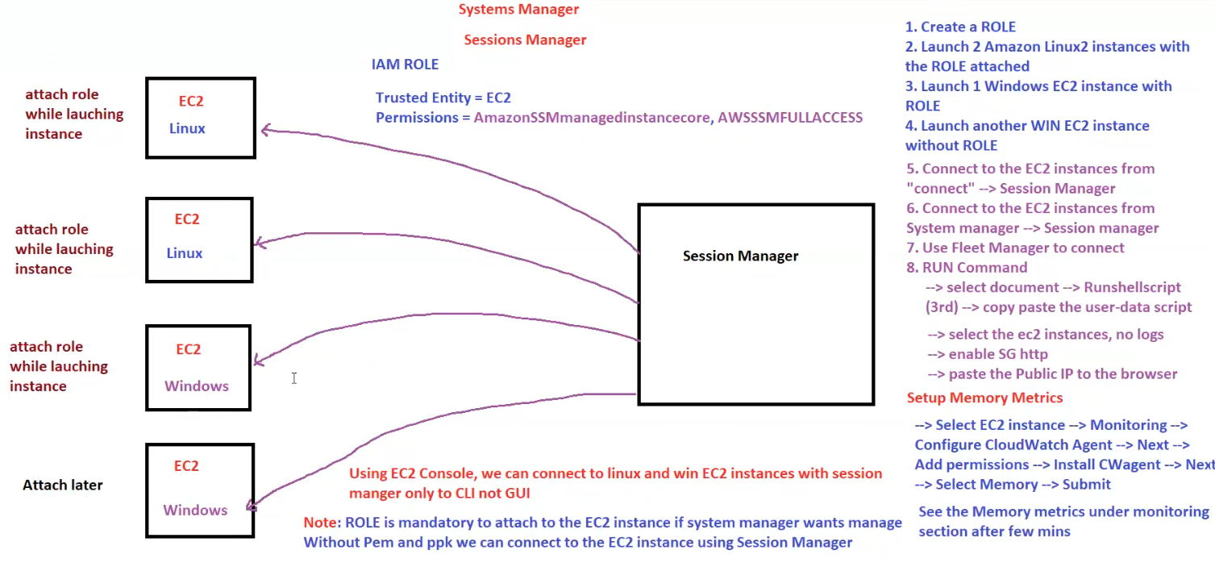

**AWS Systems Manager - Session Manager**

This diagram explains **how to connect to EC2 instances** using **AWS Systems Manager Session Manager** without SSH keys (.pem or .ppk).

**1. What is Session Manager?**

🔹 **Session Manager** is a feature of AWS Systems Manager that allows secure shell access to EC2 instances **without using SSH keys** or opening inbound ports.  
🔹 Works with both **Linux & Windows EC2 instances**.  
🔹 Requires **IAM Role with SSM permissions** attached to the EC2 instance.

**2. IAM Role Setup**

✅ **Trusted Entity:** EC2  
✅ **Permissions Required:**

* AmazonSSMManagedInstanceCore
* AWSSSMFullAccess (optional, provides full SSM access)

**3. Steps to Use Session Manager**

**Step 1: IAM Role & EC2 Instances**

1️⃣ **Create an IAM Role** with AmazonSSMManagedInstanceCore permission.  
2️⃣ **Launch 2 Amazon Linux 2 EC2 instances** and attach the IAM role.  
3️⃣ **Launch 1 Windows EC2 instance** and attach the IAM role.  
4️⃣ **Launch another Windows EC2 instance WITHOUT IAM role** (to test the difference).

**Step 2: Connect to EC2 Using Session Manager**

✅ **Method 1: From EC2 Console**

* Go to **EC2 Dashboard** → Select **Instance** → Click **Connect** → Choose **Session Manager**

✅ **Method 2: From AWS Systems Manager**

* Open **Systems Manager** → **Session Manager** → **Start a Session**

✅ **Method 3: Using Fleet Manager**

* Open **Systems Manager** → **Fleet Manager** → Select Instance

**Step 3: Run Commands via SSM**

💻 You can **run scripts on EC2** without logging in manually:  
1️⃣ Go to **AWS Systems Manager** → **Run Command**  
2️⃣ Select **Document: AWS-RunShellScript (Linux) / AWS-RunPowerShellScript (Windows)`**  
3️⃣ Copy & paste user-data script  
4️⃣ Select **EC2 instances**  
5️⃣ Enable **Security Group HTTP access**  
6️⃣ Paste **Public IP** in the browser to verify

**4. Setup Memory Metrics in CloudWatch**

🔹 **EC2 Monitoring → Install CloudWatch Agent**  
🔹 **Configure Memory Metrics → Submit**  
🔹 View under **CloudWatch Monitoring section** after a few minutes

**5. Key Takeaways**

✅ **No need for SSH keys (PEM/PPK)**  
✅ **No need to open inbound SSH ports (22, 3389)**  
✅ **IAM Role is mandatory for EC2 instances to use Session Manager**  
✅ **Easier access control & logging for compliance**

## Elastic Bean Stalk